**URL**

**(Uniform resource locator)**

**What Is a URL?**

A URL, short for a uniform resource locator serves as a web address that guides users to specific resources on the internet, including domain names, paths, and protocol identifiers.



* A URL (uniform resource locator) it’s a type of uniform resource identifier (URI) that provides a way to access information from remote computers, like a web server and cloud storage.
* URLs play a vital role in web navigation and online communication by providing a structured way to locate and access various web resources and hyperlinks.
* It contains various elements, including the network communication protocol, a subdomain, a [**domain name**](https://www.hostinger.in/domain-name-search), and its extension.

**Structure of a URL:**

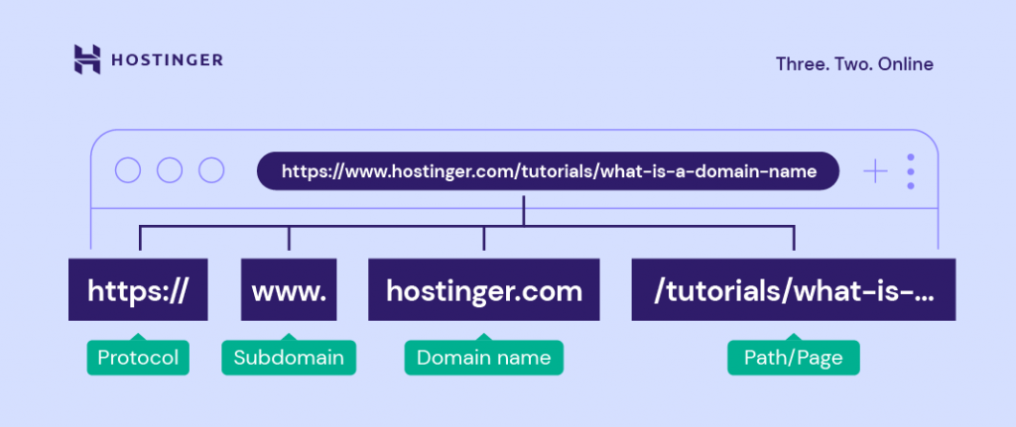

As you can see from the image, uniform resource locator (URL) contains multiple parts. To help you better understand, let’s dive deeper into the structure of a URL.

**HTTP or HTTPS:**

**[](https://www.hostinger.in/tutorials/wp-content/uploads/sites/2/2022/07/hostinger.com-uses-the-https-protocol.png)**

[HTTP (Hypertext Transfer Protocol) and HTTPS (Hypertext Transfer Protocol Secure)](https://www.hostinger.in/tutorials/http-vs-https)are protocols for network communication between web servers and browsers. They transmit messages, retrieve information through the domain name system (DNS), and return it to the browser.

The difference between HTTP and HTTPS is that the latter encrypts the data transmission process. This security protocol protects a website better and is an essential factor in improving ranking on search results.

Another difference is that HTTPS uses the Transmission Control Protocol/Internet Protocol (TCP/IP) port number 443 encrypted by Transport Layer Security (TLS). Meanwhile, an HTTP URL uses TCP/IP port number 80.

Important! Web browsers can also process other protocols, including FTP and mailto. The former allows file sharing between different web hosts, either local or remote. The latter directs users to a specific email address.

**www (Subdomain):**

**[](https://www.hostinger.in/tutorials/wp-content/uploads/sites/2/2022/07/hostinger.com-uses-the-www-subdomain.png)**

A [subdomain](https://www.hostinger.in/tutorials/what-are-subdomains) consists of any words or phrases that come before a URL’s first dot. Referring to the world wide web, www is the most common type. It indicates that a website is accessible through the internet and uses HTTP to communicate.

Furthermore, site owners can use any word as a subdomain for website organization purposes as it points to a specific directory from the primary domain. Some of the most popular options are “blog” and “news.”

**[Hostinger's knowledge base page uses the support subdomain](https://www.hostinger.in/tutorials/wp-content/uploads/sites/2/2022/07/hostinger_s-knowledge-base-page-uses-the-support-subdomain.png)**

For example, while hostinger.com uses www, the subdomain for our Knowledge Base page is “support.” Hence, the support.hostinger.com URL.

**Domain Name:**

**[hostinger.com is a domain name or a website address for Hostinger's website](https://www.hostinger.in/tutorials/wp-content/uploads/sites/2/2022/07/hostinger.com-is-a-domain-name-or-website-address-for-hostinger_s-website.png)**

A [domain name is](https://www.hostinger.in/tutorials/what-is-a-domain-name) what users type into their browser’s address bar to reach a website. It consists of a site name and an extension, for example, hostinger.com.

Every name is unique, and they represent their corresponding [IP addresses](https://www.hostinger.in/tutorials/what-is-ip-address). This unique IP address points to the website’s server. In other words, it helps users access websites easily.

**Domain Extension:**

**[Hostinger uses the .com domain extension](https://www.hostinger.in/tutorials/wp-content/uploads/sites/2/2022/07/hostinger-uses-the-.com-domain-extension.png)**

Also called a [top-level domain (TLD)](https://www.hostinger.in/tutorials/what-is-tld), is the bit following a website name. Used for around [53%](https://w3techs.com/technologies/overview/top_level_domain) of all websites, .com is the most popular extension.

Here are types of TLD extensions to consider using:

* Generic TLD (gTLD). This category includes most of the popular extensions, including .com, .org, .net.
* Country Code TLD (ccTLD). As the name suggests, this TLD indicates a country, a territory, or a geographical area. ccTLD consists of two letters based on the international country codes, such as [.mx](https://www.hostinger.in/tld/mx-domain), [.in](https://www.hostinger.in/tld/in-domain), or [.at](https://www.hostinger.in/tld/at-domain).
* Sponsored TLD (sTLD). This type of extension is sponsored and used for specific organizations. For example, Tralliance Registry Management Company, LLC sponsors .travel, and DotAsia Organization Ltd. sponsors [.asia domain extension](https://www.hostinger.in/tld/asia-domain).
* New gTLD (nTLD). It’s a [new generation of domain extensions](https://www.hostinger.in/tld). Basically, any TLD launched after 12 January 2012 are new gTLD, including .online, .store, and .tech.

**Path to the Resource:**

**[how path to resource may look like in a URL](https://www.hostinger.in/tutorials/wp-content/uploads/sites/2/2022/07/how-path-to-resource-may-look-like-in-a-URL.png)**

A path to the resource is the part to the right of the TLD. It’s often referred to as the folder structure of the website.

A path to the resource gives extra information to a web server, enabling it to lead users to a specific location. A series of paths to resources may point to a specific page, post, or file.

A URL can have more than one path to resources. When that happens, the forward-slash sign (/) will separate each of them. The more paths to resources a URL contains, the more specific the location is.

**Parameters:**

**[parameters can appear in a url as a result of a Google search](https://www.hostinger.in/tutorials/wp-content/uploads/sites/2/2022/07/parameters-can-appear-in-a-url-as-a-result-of-a-google-search.png)**

Parameters are query strings or URL variables. They’re the portion of a URL following a question mark.

Parameters contain keys and values separated by the equal sign (=). Furthermore, a URL can have multiple variables. In that case, the ampersand symbol (&) will separate each.

In terms of parameter use cases, here are some of the most common ones:

* Translating. Having a country code in the query string translates a web page to the associated country’s language.
* Searching. The searching parameter provides search results from a website’s internal search engine.
* Filtering. To separate distinct fields, such as topic, color, price range, and region, site owners can use the filtering parameter.
* Paginating. This parameter is especially useful for eCommerce websites, enabling site owners to sort content.
* Tracking. Usually contains the [Urchin Tracking Module](https://support.google.com/urchin/answer/28307) codes to track traffic from ads and marketing campaigns.

Syntax of URL:

Syntax refers to a set of rules. In the case of a URL syntax, it sets which

component and symbol are allowed in a URL. Here’s what a URL’s general syntax looks like:

<http://subdomain.domain-name.domain-extension/path-to-resource?parameters>

**Types of URLs:**

In general, the most popular types of URLs are absolute and relative. An absolute URL contains complete information, from the protocol to the path to resources or parameters. In comparison, a relative URL only includes the path to resources.

Based on the function, here are some other types of uniform resource locators:

* **Canonical URLs:** Site owners can use them in case they have duplicate content. Setting one URL as canonical is a way to let search engines know which internet address to crawl and index.
* **Callback URLs:** They refer to a home destination when users complete a process on an external system.
* **Vanity URLs:**Also known as custom short URLs, they are easy-to-remember web addresses. Typically, a vanity URL is a redirect of a longer URL. Site owners can use a website URL shortener tool, like **Bitly**, **Short.io**, and **TinyURL**, to create a vanity URL.

**Conclusion:**

A uniform resource locator (URL) is a complete web address pointing to a specific file on the internet. For example, a URL can lead users to a website, a web page, or an image.

Structure-wise, a URL consists of several elements:

* **HTTP or HTTPS:** It’s a network communication protocol connecting web servers and web browsers. The latter is more secure than the former.
* **www:** Also called a subdomain, it’s the part before a URL’s first dot. Site owners can also use any words or phrases for their website organization purposes.
* **Domain name:** Also known as a site address, it is what users type on their browsers to reach a website.
* **Domain extension:** It’s the part following a domain name, for example, **.com** and **.org**.
* **Path to the resource:** Separated by the forward-slash sign (/), this element gives extra information to a website address.
* **Parameters:**They’re often called query strings or URL variables. A question mark (?) indicates a parameter.